**WEEK 6 – REACT**

1. **myfirstreact**

function App() {

  return (

    <h1> Welcome the first session of React </h1>

  );

}

**Output:**



1. **studentapp  
   App.js**

import Home from './Components/Home';

import About from './Components/About';

import Contact from './Components/Contact';

function App() {

  return (

    <div class="container">

      <Home/>

      <About/>

      <Contact/>

    </div>

  );

}

export default App;

**Home.js**

import react, {Component} from 'react';

class Home extends Component{

    render(){

        return(

        <div>

        <h3> Welcome to the Home Page to Student Management Portal </h3>

        </div>

        );

    }

}

export default Home;

**About.js**

import react, {Component} from 'react';

class About extends Component{

    render(){

        return(

        <div>

        <h3> Welcome to the About Page to Student Management Portal </h3>

        </div>

        );

    }

}

export default About;

**Contact.js**

import react, {Component} from 'react';

class Contact extends Component{

    render(){

        return(

        <div>

        <h3> Welcome to the Contact Page to Student Management Portal </h3>

        </div>

        );

    }

}

export default Contact;

**Output:**

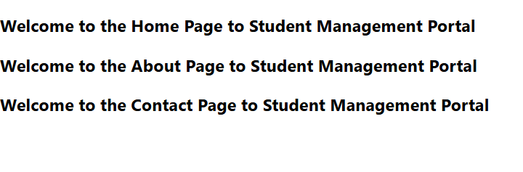

1. **scorecalculatorapp**

**App.js**

import { CalculateScore } from './Components/CalculateScore';

function App() {

return (

<div>

<CalculateScore

Name="Steeve"

School="DNV Public School"

total={284}

goal={3}

/>

</div>

);

}

export default App;

**CalculateScore.js**

import './Stylesheets/mystyle.css';

const percentToDecimal = (decimal) => {

return (decimal.toFixed(2) + '%');

};

const calcScore = (total, goal) => {

return percentToDecimal(total / goal);

};

export const CalculateScore = ({ Name, School, total, goal }) => (

<div className="formatstyle">

<h1><font color="Brown">Student Details:</font></h1>

<div className="Name">

<b><span> Name: </span></b>

<span>{Name}</span>

</div>

<div className="School">

<b><span> School: </span></b>

<span>{School}</span>

</div>

<div className="Total">

<b><span>Total:</span></b>

<span>{total}</span>

<span>Marks</span>

</div>

<div className="Score">

<b>Score:</b>

<span>

{calcScore(

total,

goal

)}

</span>

</div>

</div>

);

**/Stylesheets/mystyle.css**

.Name {

font-weight: 300;

color: blue;

}

.School {

color: crimson;

}

.Total {

color: darkmagenta;

}

.formatstyle {

text-align: center;

font-size: large;

}

.Score {

color: forestgreen;

}

**Output**

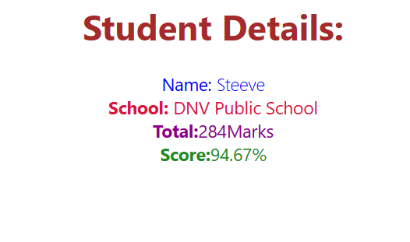

1. **blogapp**

**Post.js**

class Post{

    constructor(id,title,body){

        this.id=id;

        this.title=title;

        this.body=body;

    }

}

export default Post;

**Posts.js**

import React from "react";

import Post from "./Post"; // Your data class

// Optionally: define a functional display component here instead of using Post as data

class Posts extends React.Component {

  constructor(props) {

    super(props);

    this.state = {

      posts: [],

      hasError: false

    };

  }

  loadPosts() {

    fetch("https://jsonplaceholder.typicode.com/posts")

      .then((res) => res.json())

      .then((data) => {

        const posts = data.map(item => new Post(item.id, item.title, item.body));

        this.setState({ posts });

      })

      .catch((error) => {

        console.error("Error while fetching:", error);

        this.setState({ hasError: true });

      });

  }

  componentDidMount() {

    this.loadPosts();

  }

  componentDidCatch(error, info) {

    console.error("Caught error:", error, info);

    alert("Something went wrong!");

    this.setState({ hasError: true });

  }

  render() {

    if (this.state.hasError) {

      return <h2>Error loading posts.</h2>;

    }

    return (

      <div>

        <h1>Blog Posts</h1>

        {this.state.posts.map(post => (

          <div key={post.id} style={{ border: "1px solid #ccc", padding: "10px", marginBottom: "10px" }}>

            <h3>{post.title}</h3>

            <p>{post.body}</p>

          </div>

        ))}

      </div>

    );

  }

}

export default Posts;

**App.js**

import React from "react";

import Posts from "./Posts";

function App() {

  return (

    <div className="App">

      <Posts />

    </div>

  );

}

export default App;

**Output**

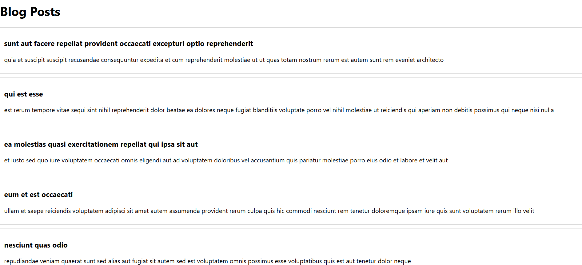

1. **cohorttracker**

**CohortDetails.module.css**

.box {

  width: 300px;

  display: inline-block;

  margin: 10px;

  padding: 10px 20px;

  border: 1px solid black;

  border-radius: 10px;

}

dt {

  font-weight: 500;

}

.green {

  color: green;

}

.blue {

  color: blue;

}

**CohortDetails.js**

import styles from './CohortDetails.module.css';

function CohortDetails(props) {

    const status = props.cohort.currentStatus.toLowerCase().trim();

    const headingClass = status === 'ongoing' ? styles.green : styles.blue;

    return (

        <div className={styles.box}>

            <h3 className={headingClass}>

                {props.cohort.cohortCode} -

                <span>{props.cohort.technology}</span>

            </h3>

            <dl>

                <dt>Started On</dt>

                <dd>{props.cohort.startDate}</dd>

                <dt>Current Status</dt>

                <dd>{props.cohort.currentStatus}</dd>

                <dt>Coach</dt>

                <dd>{props.cohort.coachName}</dd>

                <dt>Trainer</dt>

                <dd>{props.cohort.trainerName}</dd>

            </dl>

        </div>

    );

}

export default CohortDetails;

**App.js**

import './App.css';

import { CohortsData} from './Cohort'

import CohortDetails from './CohortDetails';

function App() {

  return (

  <div>

    <h1>Cohorts Details</h1>

    {CohortsData.map(cohort => <CohortDetails cohort={cohort}/>)}

  </div>

  );

}

export default App;

**Output**

